Brad Anderson

ESM 244 |Winter 2018

## Assignment 2

*Parameter Estimation – Wild Fish Catch*

$$N\left(t\right)=\frac{ 100.28}{1+4.32e^{-0.07t} }$$

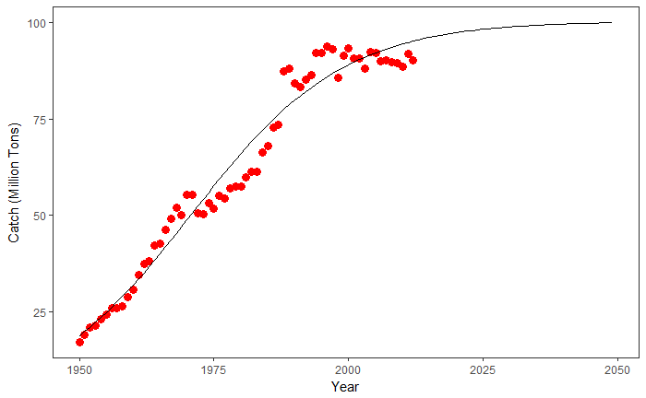

Figure 1: Global Wild Fish Catch. Historical data from 1915 to 2012, with non-linear model projection of future catch. Source: Earth Policy Institute with 1950-2010 from U.N. Food and Agriculture Organization (FAO), Global Capture Production and Global Aquaculture Production, electronic databases, at www.fao.org/fishery/topic/16140/en, updated March 2012